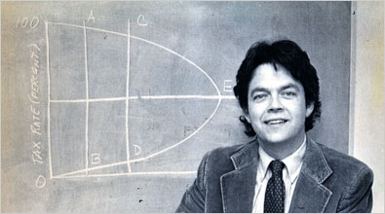
Reaganomics

The term Reaganomics was used to describe, and decry, the economic policies of U.S. President Ronald Reagan during the 1980s. Reagan had inherited an economy with high inflation and unemployment from President Jimmy Carter(1976-1980), and his economic theories are claimed by his supporters to have eventually led to a strong recovery.

Reagan supported supply side economics. Supply side policies offered one theory on how to improve the functioning of the economy and its productive capacity. The large, across the board tax cuts initiated by Reagan at the start of his administration, are an example of supply side economics. This is contrary to the "demand-side" economics of traditional Keynesianism, which tries to bring the economy to its existing full capacity by means of increasing demand, primarily through fiscal policy. In the 1970s, many on the right became critical of Keynesianism, which they claimed brought higher inflation without any gains in employment. However, true Keynesianism, which called for deficit spending during recessions and surplus spending during periods of prosperity, was rarely implemented in its totality in American politics, usually because political considerations overshadowed fiscal policy.

The Tax Reform Act of 1986, which had broad bipartisan support, partly implemented the principles of supply-side economics. It drastically cut the top tax rate, which Congressional Democrats criticized because it seemed to benefit only the wealthiest Americans. It also simplified the tax code and eliminated tax loopholes, which had the support of Congressional Democrats.

Part of what Reagan implemented was in fact not supply side economics, but rather his own version of Keynesianism. Reagan advocated initiating deep tax cuts and simultaneous increases in military spending, while at the same time claiming that the the Federal deficit would be erased. Critics argued that while Keynesian economics promoted the idea of consumers creating jobs by increasing the demand for goods and services, Reaganomics relied on giving more money to producers by giving tax cuts especially to the wealthiest citizens, who would then create jobs that would somehow find a demand. This type of economic theory has also been referred to derisively as "trickle-down economics".

The belief of Reaganomics that the tax cuts would more than pay for themselves was influenced by the so-called Laffer Curve, a theoretical taxation model that was particularly in vogue among some American conservatives during the 1970s. Originally sketched on a napkin by Art Laffer, who later became an advisor in the Reagan administration, the curve was an upside-down "U" plotted on a graph. The horizontal axis represented tax rates, and the vertical axis represented revenues. The theory was that, if taxes were too high, government revenues actually dropped by lowering incentives to produce. The rise, rather than fall, in government deficits during the Reagan era caused many to question to validity of the Laffer curve. In addition, although the Laffer curve was used to justify tax cuts, its main emphasis was on showing how to maximize government revenues through fiscal policy; because this conflicted with the aim of conservatives to reduce spending as well as revenues, the Laffer curve has more recently been deemphasized by conservatives in recent years. Nonetheless, Federal Government tax revenues did increase significantly following the tax cuts of the Reagan years; it was the dramatic increase in spending that produced the budget deficits of that era.

Before Reagan's election, Reaganomics was considered extreme by the liberal wing of the Republican Party. While running against Reagan for the Presidential nomination in 1980, George Bush had derided Reaganomics as "voodoo economics", a term that held currency long after the recession ended. Similarly, in 1976, Gerald Ford had severely criticized Reagan's proposal to turn back a large part of the Federal budget to the states. After the Reagan election, however, most Republicans endorsed Reaganomics, including Bush, who became Reagan's Vice President.
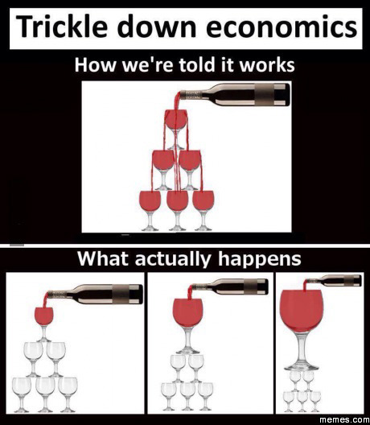
How Believers in Reganomics say it works
How critics of Reganomics say it works

