Name: ________________________________________________ Date: ___________________ Period: ____________

Crash Couse in World History: 15th Century Mariners

The interconnection of the Eastern and Western hemispheres made possible by transoceanic voyaging marked a key transformation of this period. Technological innovations helped to make transoceanic connections possible.

Changing patterns of long-distance trade included
- the global circulation of some commodities and
- the formation of new regional markets and financial centers.

Increased transregional and global trade networks facilitated
- the spread of religion and
- other elements of culture
- migration of large numbers of people.

Germs carried to the Americas ravaged the indigenous peoples, while the global exchange of crops and animals altered agriculture, diets, and populations around the planet.
In the context of the new global circulation of goods, there was an intensification of all existing regional trade networks that brought prosperity and economic disruption to the merchants and governments in the trading regions of the Indian Ocean, Mediterranean, Sahara, and overland Eurasia.
European technological developments in cartography and navigation built on previous knowledge developed in the classical, Islamic, and Asian worlds, which made transoceanic travel and trade possible. This included
- production of new tools--astrolabe, new maps
- innovations in ship designs--caravels
- improved understanding of global wind and currents patterns

Directions:
- Preview the video viewing questions.
- Watch “Crash Couse in World History: 15th Century Mariners” without taking any notes.
- Watch “Crash Couse in World History: 15th Century Mariners” a second time. We will pause the video after each section so that you can take notes.
- Meet and Greet classmates to obtain notes you missed.

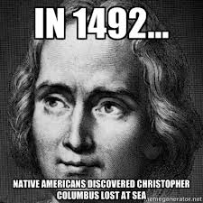
Name: ___________________________ Date: _________ Period: ________

Crash Couse in World History: 15th Century Mariners

- Why were the European powers interested in getting involved in the Indian Ocean trade routes?

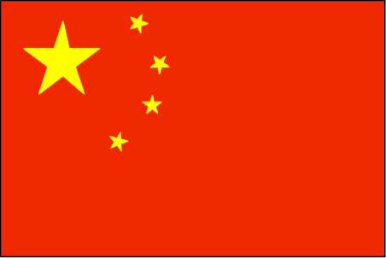
Zheng He--CHINA
- Circle the correct answer—who had more ships,

Zheng He or Columbus?

- Circle the correct answer—who had bigger ships,

Zheng He or Columbus?

- What were the purposes of Zheng He’s expeditions?

- What did Zheng He bring back to China?

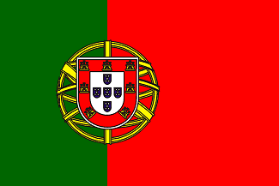
Vasco da Gama--PORTUGAL
- What was learned at Prince Henry’s school of navigation?

- What were the Portuguese motivations for exploration?

- What is a “trading post empire”?

- Why were the Portuguese similar to Indian Ocean pirates?

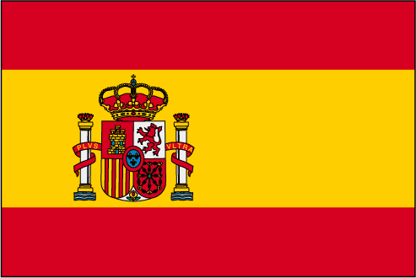
Christopher Columbus—SPAIN
- Which 2 countries did the Line of Demarcation involve? What was the agreement?

- Why did Spain fund Columbus’ expeditions?

- Why can we say we truly have world history?

